Project Design Phase
Solution Architecture
Date | 09-07-2026
Team ID
Project Name | SB Stocks - Stock Trading Application (MERN)
Maximum Marks | 4 Marks

Solution Architecture:
Solution architecture is a complex process - with many sub-processes - that bridges the gap between business problems and technology solutions. Its goals are to:
- Find the best tech solution to solve existing business problems.
- Describe the structure, characteristics, behavior, and other aspects of the software to project stakeholders.
- Define features, development phases, and solution requirements.
- Provide specifications according to which the solution is defined, managed, and delivered.

SB Stocks - Solution Architecture Diagram:
The diagram below shows the end-to-end architecture and data flow of SB Stocks - from the React client, through the Express/Node.js REST API and authentication middleware, to the MongoDB data layer and external stock market data / email services.
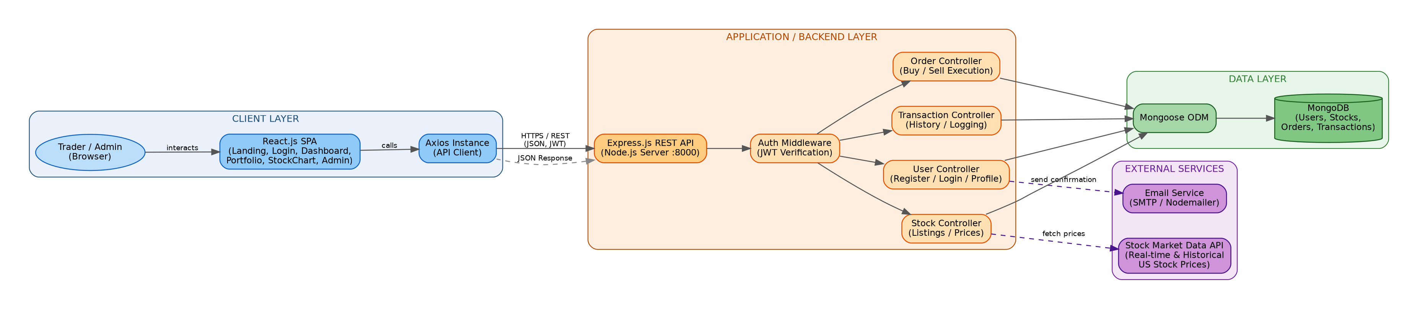
Figure 1: Architecture and data flow of the SB Stocks paper trading application
Reference:
https://c4model.com/

